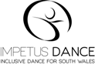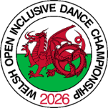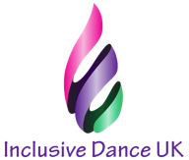

ENTRY FORM
WELSH OPEN INCLUSIVE DANCE CHAMPIONSHIP 2026

HALO Bridgend Life Centre, Angel Street, Bridgend, South Wales, UK, CF31 4AH

Sunday 22nd February 2026
Please use a separate form for each couple
Country

Couple
Names:
Address:
Phone:
e-mail:
 | Wheelchair user/Standing | Wheelchair user/Standing
Class | Class 1 – Class 2 | Class 1 – Class 2
D Class Standard | Combi / Duo / Standing | Combi / Duo / Standing
D Class Latin | Combi / Duo / Standing | Combi / Duo / Standing
A Class or Main | A Class/ Main Class | A Class/ Main Class
Combi Standard
Combi Latin
Duo Standard
Duo Latin
Standing
Single Men | D Class / A class / Main Class | D Class / A class / Main Class
Single Women | D Class / A class / Main Class | D Class / A class / Main Class
Freestyle | D Class / A class / Main Class | D Class / A class / Main Class
 | Combi / Duo / Singles | Combi / Duo / Singles
Group Dance
Class Senior
Blind, Deaf, M
(please indicate who)
Entry Fee | £20.00 | £20.00
Spectators  Adult  Child | Number @ £5.00  £2.50 | Total £

Names of spectators  1.  2.  3.  4. | Telephone Number of Spectators

Entry Fee £20.00 per person.

All ordered entries and tickets can be paid with entries by sending us a cheque or Bank payment to:

Impetus dance Community Interest Company –
Natwest Bank
Sort code: 60-16-48
Acc: 84098570

Signature: Date:

Please return by 7th February 2026 to: Lou Bowman –

Impetus Dance Community Interest Company,
15, Maerdy Park,
Pencoed,
Bridgend,
Wales,
CF35 5HJ, UK

or by email to: impetusdance@outlook.com

