HOTELS
- Days Hotel Sarn Services Junction 36 M4 (2 mins off junction) (hosts only 1 accessible room)
2 night stay approx. from £178.98 for 2 people.
KFC / Burger King in service station across car park. 5 min drive from outlet village (Wagamama’s / Nando’s / 5 guys / chopsticks / Miller & Carter / KFC
Approximately 10 mins drive to event venue
Days Inn Bridgend Cardiff - Guest Reservations

- Premiere Inn Bridgend Junction 36 M4 (just off junction) (hosts only 1 accessible room)
2 night stay approx. from £185.00 (non-refundable) for 2 people
Miller & Carter next door, KFC other side of car park, food hall with Wagamama’s / Frankie & Bennie’s / Nando’s / Pizza Hut all short 5 mins walk across Sainsburys car park
Approximately 10 mins drive to event venue
PLEASE NOTE: there are few rooms left at the Pencoed Premiere Inn off junction 35 of M4 and no Accessible rooms left.
Search results | Premier Inn

- Travel Lodge Pencoed Junction 35 M4 (3 min drive off junction) (only hosts 2 accessible rooms)
2 nights stay £162.98 (saver) for 2 people.
Harvester next door
Approximately 20 mins drive to event venue. Not on bus route and not on train route.
Travelodge | Bridgend Pencoed hotel - Bridgend Pencoed hotels
- The Best Western Heronston Hotel Bridgend 15 mins from junction 35 M4 (hosts only 1 accessible room with bath no shower) Not an overly accessible room in my mind!
2 nights stay approx. £418 (saver/non-refundable) for 2 people.
Restaurant on site, Old Mill Brains pub 3 min drive, Mc Donald’s 5 min drive, Dominos / Toby Carvery / 7 min drive
Approximately 5 mins drive to event venue. Not on bus route and not on train route.
Best Western Premier Heronston Hotel & Spa | Hotels in Cardiff

- The Vale Resort Junction 34 M4 (3 mins off junction by car) (hosts only 3 accessible rooms)
2 nights stay £173.83 (room only non-refundable) for 2 people. Couldn’t see any information about accessible rooms.
Restaurant on site
Approximately 23 mins drive to event venue. Not on bus route and not on train route.
Hotel, Golf, & Spa - South Wales - The Vale Resort

- Premiere Inn Llantrisant junction 34 M4 (7 mins from junction) (hosts only 2 accessible rooms)
2 night stay £237.00 (non-refundable) for 2 people
Longbow beefeater pub next door
Approximately 25-30 mins drive to event venue. Close to hospital bus route (Pontypridd-Bridgend) would need taxi from Bridgend centre to Sarn then.
Search results | Premier Inn

- The village Hotel Cardiff junction 32 M4 (just off junction) (hosts 3 accessible rooms)
2 nights stay £207 (room only non-refundable)
Restaurant on site. Mc Donald’s 2 min drive. Italian / Indian / Chinese and 2 Bistro Gastro pub restaurants 10 min drive in Whitchurch Village also on regular bus route to village.
Approximately 30 mins drive to event venue. Close to train and bus route to Cardiff city centre where you would have to get train to Bridgend or Sarn.
Village Hotel Cardiff | Hotel Near Principality Stadium

TRAVEL:
NOTE:
There is no regular bus or train link directly between hotels and event venue. If transportation is required there are a few accessible taxi’s locally:
Danny’s Taxi 07788900799
Bridgend Community Transport 01656 669665
(you will need to prebook this transport a few weeks before event if using this team) Mini bus with tail gate lift and locking wheelchair system for 2 chairs at a time and 5 seated as well.
Buses:
Bridgend, Bridgend – Bus Times – this provides online information for local and regional bus times.
First Cymru Buses X2 from Cardiff to Bridgend – Run every hour and the journey takes approx 1hr.
See time below taken from their website South & West Wales | First Bus –
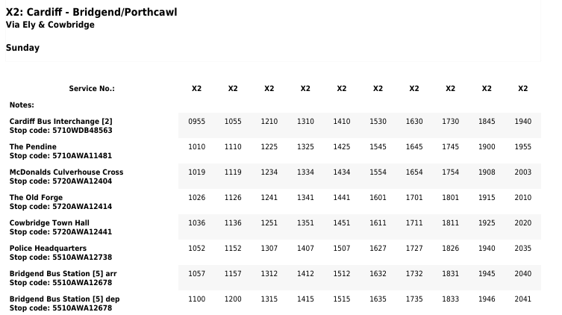
Buses are limited on Sundays.
Bridgend train station and bus station are both at walking distance from HALO Life Centre based in the main area of Bridgend town. They both take approximately 10-15 minutes to walk/roll too. There is no direct bus. There are also taxi ranks outside both the bus and train station.
There are only 2 buses back to the airport from Bridgend on a Sunday, number 303 & 304 and both take over 3 hours. We suggest you return on Monday as easier to catch buses/trains and a flight out of Cardiff. You can find more information on the links above.
Trains:
To view timetables and book please click here - Trainline : Search, Compare & Buy Cheap Train Tickets
Trains run daily. On a Saturday they run from Cardiff International Airport Roose to Bridgend train station and this is a direct route taking 26 mins. They run every hour. On return to Cardiff airport from Bridgend on a Sunday they run directly every hour too, single fare is £3.80
If travelling back to airport from Bridgend train station on a Monday they run every hour from 05.40 till late.
Trains run direct from Cardiff Central Station to Bridgend roughly every 20-30 mins from 08:04am on Sundays till late. There are two types of train, the London – Swansea train is direct from Cardiff to Bridgend, or there are local trains that take a bit longer as they stop at all the local stations between Cardiff and Bridgend. The link above can show you all routes.
Travel by car:
The Bridgend HALO Life Centre is about 5-7 minutes’ drive from the M4 junction of the motorway.
Parking at the venue:
There are plenty of accessible car parking spaces at the front of the building or at the back of there building there are a further 4 spaces under the bowls hall. Please note parking even with a blue badge is charged at £3 a day in the bowls hall car park and also at HALO. If you park in HALO please ensure you inform reception so they can add you to their parking system. Payment machines are in the car park in 2 locations and take coins and card.
Eating out in Bridgend:
Bridgend has an abundance of places to eat out. Bridgend town boasts some of the best restaurants in Wales and has won the award for best town to eat out in the UK 2023. Mc Arthur Glen close to the M4 motorway junction 36 also has a few restaurants (Mowgli, Five Guys, Wagamama’s, Costa, Starbucks & Greggs)
Sight-seeing:
Bridgend is close to the coast. There is a lovely sandy beach called Rest Bay just outside Porthcawl which is about a 15-20 min drive from Bridgend and there is a car park and café at a height where you can see across to England on a clear day. There is also a beach to the left of the harbour in Porthcawl Coney Beach. Both beaches have a beach wheelchair where you can access the beach direct and the sea if you choose to dare the cold in Winter!
Bridgend is also close to the Mountains and the famous Brecon Beacon National Park or now known as Bannau Brycheiniog. There are plenty of accessible walking paths and cycle routes and some waterfalls to visit but please note these paths are terribly wet during the winter months. The area can be reach within approximately 45 mins- 1 hour by car from Bridgend.
Cardiff Bay is always a lovely place to visit with plenty of bars and restaurants as well as a dance and opera house on the waterfront. Cardiff is about a 20 minute drive
If you like shopping there is a designer outlet village shopping centre in Bridgend, McArthur Glen where you can buy designer branded clothes at cheaper prices or alternatively visit the St Davids shopping centre in Cardiff City Centre which is always a very pleasant place to shop and eat out. The city is about a 25 minute drive from Bridgend.

Travel to the venue:
- Take junction 36 of M4 heading south (left) towards Bridgend A4061 (dual carriageway)
- at the first roundabout go straight over
- At the second roundabout take the 1st left following the same road.
- At the next roundabout take the 3rd exit towards Bridgend town & train station remaining on the dual carriageway.
- At the next roundabout go straight over.
- When you come to the traffic light junction remain on the dual carriageway going under the railway bridge and stay in the left lane as you go over the river bridge with bus station on left.
- At the final smaller roundabout (just past Tesco) turn left remaining on dual carriageway in the left lane.
- At the traffic lights (Bridgend Council Civic offices ahead of you) turn left into Angel Street. Follow road down straight through lights and under road bridge.
- At this stage HALO Bridgend Life Centre is on your left and the fire brigade is on your right.
- Turn left into the centre and park close to the front entrance where there is designated Accessible parking or drive around the right side of the building where there is further parking. HALO car parking is charged per day at car parking machines £3 a day.
- Alternatively there is a council ran car park at the back of the centre which also has a few accessible spaces and they too charge £3 a day.
- You will be guided by the chaps from the charity Lads and Dads in orange hats and high viz jackets into the building. If you require support please ask them and they will assist you.
